**Java Annotations**

* Special labels/markers added to Java Classes
* Provide meta-data about the class
* Processed at compile time or run-time for special processing

**Why use Annotations over Spring configuration**

* XML configuration can be verbose
* Annotations minimizes the XML configuration

**Scanning for Component Classes**

* Spring will scan your Java classes for special annotations
* Automatically register the beans in the Spring container

**Development Process**

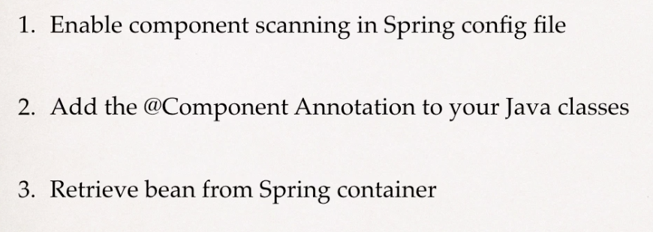

A screenshot of a cell phone


A screenshot of a social media post

